**DEPARTMENT OF MECHANICAL ENGINEERING  
  
Subject: Fundamentals of Programming  
Lab Task 5  
Submitted by: Zahoor Azam  
Registration number: 453972  
Semester No. 1  
Date: October 26, 2023**

**FIRST PROGRAM**

#include<iostream>

using namespace std;

int main(){

int x = 1;

do {

cout << "enter a number: ";

cin >> x;

} while (x > 0);

}

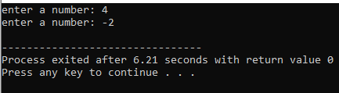

**SECOND PROGRAM**

#include <iostream>

#include<math.h>

using namespace std;

int main() {

int a, b , ans=0 ,i;

char operation;

do {

cout<<"Enter first number"<<endl;

cin>>a;

cout<<"Enter second number"<<endl;

cin>>b;

cout<<"Enter operation(+ for addition , - for subtaction , * for multiplication , / for division , % for modulus , ^ for power)"<<endl;

cin>>operation;

switch (operation) {

case '+':

ans=a+b;

break;

case '-':

ans=a-b;

break;

case '*':

ans=a*b;

break;

case '/':

if (b==0) {

cout<<"invalid denominator"<<endl;

}

ans=a/b;

break;

case '%':

if (b==0) {

cout<<"invalid second number"<<endl;

}

ans=a%b;

break;

case '^':

ans=pow(a,b);

default:

cout<<"invalid operation try again"<<endl;

}

cout<<ans <<endl;

cout<<"press 1 to continue and 0 for termination"<<endl;

cin>>i;

}

while (i==1);

return 0;

}

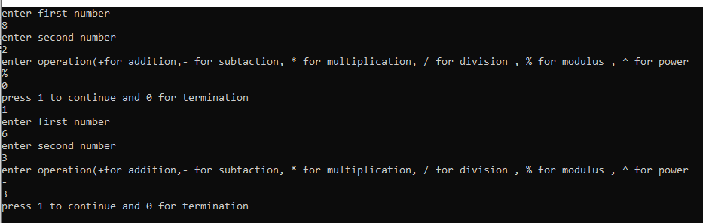

**THIRD PROGRAM**

**Part a**

#include <iostream>

#include<math.h>

using namespace std;

int main() {

int x=2,sum=0;

while (x<=100) {

if (x%2==0) {

sum =sum+x;

}

x++;

}

cout<<sum<<endl;

}

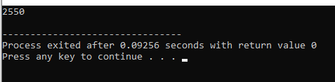

**Part b**

#include <iostream>

#include<math.h>

using namespace std;

int main() {

int x=1,sum=0;

while (x<=100) {

sum=sum + x*x;

x++;

}

cout<<sum<<endl;

}

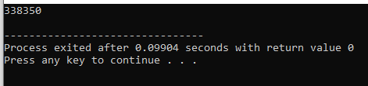

**FOURTH PROGRAM**

**Part a**

#include <iostream>

#include<math.h>

using namespace std;

int main() {

int x=0;

while (x<=20) {

cout<<pow(2,x)<<endl;

x++;

}

}

**Part b**

#include <iostream>

#include<math.h>

using namespace std;

int main() {

int a,b , sum=0 ;

cout<<"enter 1st number"<<endl;

cin>>a;

cout<<"enter 2nd number"<<endl;

cin>>b;

while (a<=b ) {

if (a%2==1 ) {

sum=sum+a;

}

a++;

}

cout<<sum<<endl;

}

